Toronto Metropolitan University

Lab Report 5:

The Metal-Oxide-Semiconductor Field-Effect Transistor (MOSFET)

Cheng, Vincent 501173673
Mourad, Shai 501170415
PCS 224 Section 09/14
Professor X. Yuan
T.A Revin Toquero
28 November, 2023

Introduction
The lab aims to explore MOSFET behavior using an Arduino-powered circuit by measuring drain voltages and drain current under different gate voltages. The analysis focused on understanding MOSFET responses to different voltage combinations, particularly examining drain current versus drain voltage graphs and determining threshold voltage and transconductance gain from drain current versus gate voltage data.

Theory
A MOSFET, a type of transistor with gate, source, and drain terminals, serves as an electrically driven switch. There are two main types: depletion and enhancement, with n-channel or p-channel substrates. The lab utilizes an n-channel enhancement mode MOSFET.

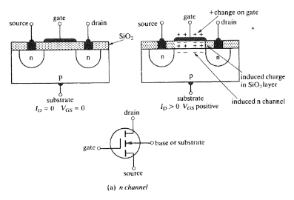
Figure 1: Structure and Schematic of n-channel enhancement mode MOSFET
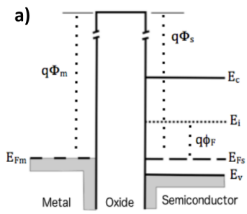
Figure 2: Flat band where VG = 0 volts
When VG is 0V, Fermi energy levels align, forming a "flat band." Substrate is strongly p-type, and hole concentration (p) is given by:
$p=N_{a}^{\frac{E_{F}-E_{V}}{KT}}$

Equation (1)
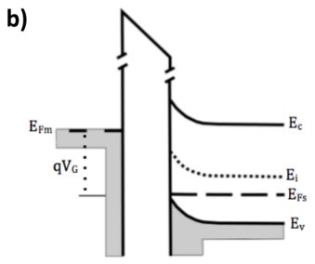
Figure 3: Accumulation state where VG < 0 volts
Negative charges at the gate attract holes, causing band bending. Increased charge carrier density defines the "accumulation" state. Capacitance is
$C_{ox}=\frac{ϵ_{ox}}{d_{ox}}$

Equation (2)
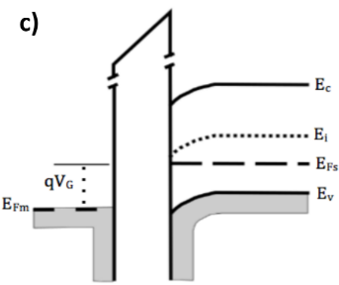
Figure 4: Depletion state where VG > 0 volts
Positive charges at the gate induce depletion, reducing the p-type semiconductor. Depletion width (W) is determined by:
$W=[\frac{2ϵ_{s}(ϕ_{s})}{qN_{a}}]^{1/2}$

Equation (3)
Capacitance is:
$C_{d}=\frac{ϵ_{s}}{W}$

Equation (4)
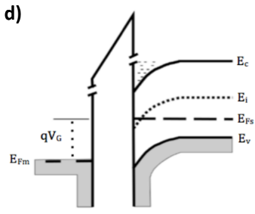
Figure 5: Inversion state where VG >> 0 volts
As VG exceeds a threshold (VT), an inversion state forms an n-channel. Depletion layer depth is maximum, and total capacitance is minimum:
$C=\frac{C_{ox}C_{d}}{C_{ox}{+C}_{d}}$

Equation (5)
The primary objective of this lab is to observe and document the device's behavior in the inversion state as VDS undergoes variation. At small VDS, the current is directly proportional to VDS. As VDS increases, and VG surpasses VT, all charge carriers are effectively swept from drain to source. The challenge lies in measuring or calculating the current and other associated parameters.
When VGS significantly exceeds VT, the MOSFET transitions into the non-saturated region, characterized by drain current represented as:
$I_{D}=K_{n}[2(V_{GS}-V_{TN})V_{DS}-V_{DS}^{2}]$

Equation (6)
Here, the transduction parameter is:
$K_{n}=\frac{Wμ_{n}C_{ox}}{2L}$

Equation (6)
In the linear (non-saturated) region, with very small VDS, the drain current is given by:
$I_{D}=K_{n}[2(V_{GS}-V_{TN})V_{DS}]$

Equation (7)
For the saturated region, the drain current is expressed as:
$I_{D}=K_{n}(V_{GS}-V_{TN})^{2}$

Equation (8)
Here, the transduction parameter is:
$K_{n}=\frac{Wμ_{n}C_{ox}}{2L}$

Equation (9)
It's important to note that this equation assumes infinite output impedance, implying that the current ID remains constant when VDS is large, making it applicable under specific conditions. The final principle of interest is the transconductance gain, given by:
$g_{fs}=\frac{∂I_{DS}}{∂V_{GS}}$

Equation (10)

Procedure

Connect the jumper wires to the breadboard to match the I-V Curve Tracer Circuit Layout and Arduino board to the computer. Upload the Arduino code to the board and collect the $I_{D}$ vs $V_{DS}$ data using different gate voltages ($V_{GS}$), beginning at 5V until 1V is reached, decreasing each trial by 1V. Plug the board into a 9V power supply when collecting data. Use the serial monitor to obtain $V_{DS}$ and ID values. Alter the program’s code to measure $I_{D}$ and $V_{GS}$ when $V_{DS}$ is set to 5 volts. Disconnect the Arduino board and return the materials. Using the data from the serial monitor, create two graphs; one for I_{D} vs V_{GS} and another for I_{D} vs V_{DS}. The I_{D} vs V_{DS} graph should contain five different curves, one for each voltage of V_{GS}. Observe the I_{D} vs V_{GS} graph and locate the V_{GS} value at which the slope becomes a constant positive value. This is the V_{T}. Calculate The Transconductance Gain (gfs). Compare and comment on the collected values to the theoretical values using a datasheet for the given transistor. Calculate a percent error to prove the accuracy of the collected data. Create a conceptual MOSFET Switch and give it a V_{DD} and P based on one’s student ID. Find the current of the switch and then calculate the dissipated power. Find the V_{DS} based on the previously created graphs and the found V_{T} value. Use the transistor datasheet to make sure the switch would realistically work, by comparing the P_{Diss} and P_{max}.

Apparatus
- MOSFET transistor (2N7000, ZVN2106, or similar)
- Arduino ( Adafruit Metro Mini, or suitable alternative version)
- Adafruit MCP4745 12-bit 5V DAC breakout board (2 required)
- Adafruit INA219 DC High-Side Current Sensor breakout board
- MCP4002 dual op-amp (CMOS)
- TIP41C BJT transistor and external power supply
- Electrical prototyping board
- Barrel jack receiver
- 9V power supply (barrel jack)
- Jumper wires

Results and Data
Table 1.0: Data Trends of ID and VDS for the Each VGS value
VGS = 5.00V |  | VGS = 4.00V |  | VGS = 3.00V |  | VGS = 2.00V |  | VGS = 1.00V
VDS (V) | ID (mA) | VDS (V) | ID (mA) | VDS (V) | ID (mA) | VDS (V) | ID (mA) | VDS (V) | ID (mA)
0.00 | -0.10 | 0.00 | -0.20 | 0.00 | 0.10 | 0.00 | 0.00 | 1.04 | -0.20
1.01 | 441.50 | 1.01 | 313.40 | 1.00 | 81.60 | 1.00 | 0.10 | 2.01 | 0.10
2.00 | 694.20 | 2.01 | 396.10 | 2.00 | 84.60 | 2.02 | 0.10 | 3.02 | -0.20
3.01 | 767.20 | 3.02 | 401.50 | 3.02 | 85.50 | 3.00 | 0.00 | 4.00 | -0.10
3.11 | 756.00 | 3.67 | 399.80 | 4.07 | 86.20 | 4.32 | 0.20 | 4.36 | -0.20

Table 2.0: Data Trends of ID and VGS at VDS = 5.00V
VDS (V) | ID (mA)
0.00 | 0.00
1.03 | 0.00
2.00 | 0.20
3.00 | 86.20
4.00 | 407.40
4.98 | 766.10

Figure 4.0: Graph of I_{D} Versus V_{DS} for Differing Values of VGS
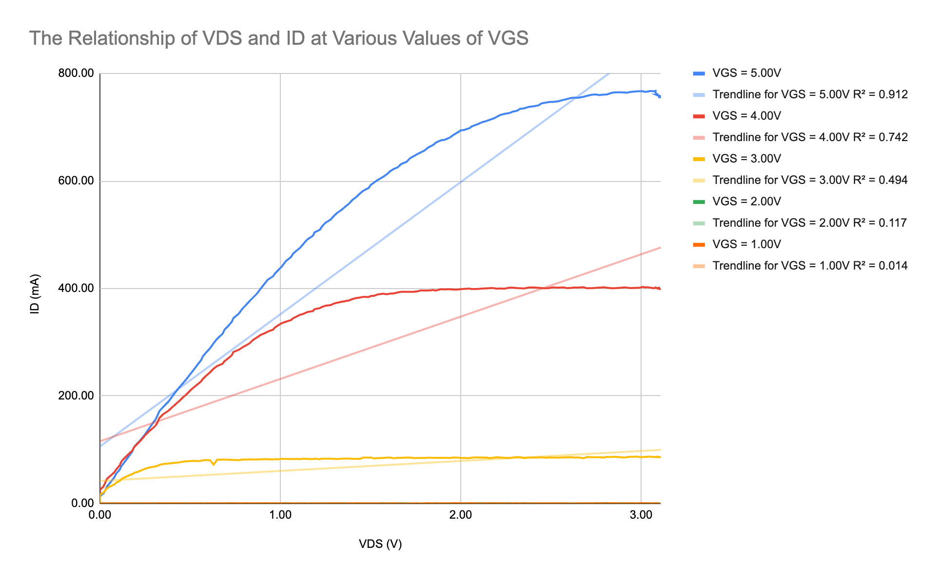

Figure 5.0: Graph of I_{D} versus V_{GS} for V_{DS} = 5.00V
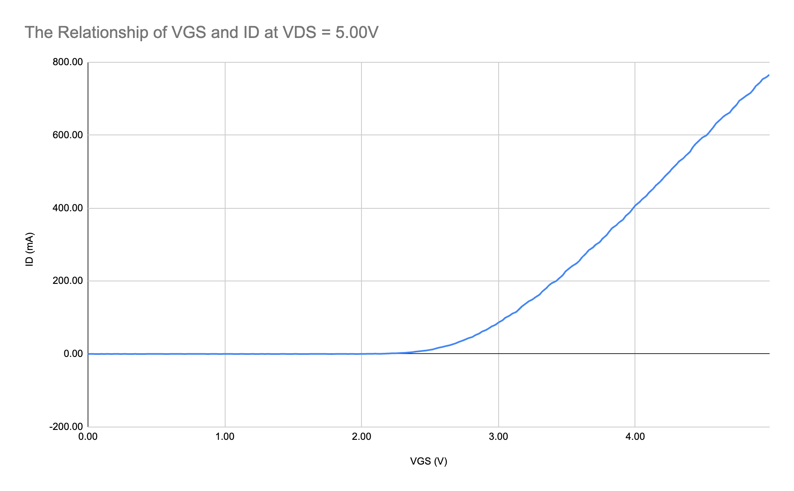

Analysis and Calculation
By observing figure 4.0, it can be observed that an increase in V_{GS} results in a higher slope and maximum I_{D}. From figure 5.0, it can be seen that the threshold or turn-on voltage (V_{T}) is where the slope becomes constant. This is around 3.00V, which means that V_{T} = 3.00V.

Calculating The Transconductance Gain (g_{fs}):
$g_{fs} = \frac{∆ID}{∆VGS} = \frac{{ID}_{max} - {ID}_{min}}{{VGS}_{max} - {VGS}_{min}}$

$= \frac{766.10mA - 0.00mA}{4.98V - 0.00V}$

$g_{fs}= 153.84\frac{mA}{V}$

By observing figure 4.0, the resulting graph matches the theoretical outcome of the experiment. This can be true since both the slope and I_{D} increase as V_{GS} increases. Additionally, V_{GS} has a lesser effect on I_{D} as V_{DS} increases.

By comparing the gfs on the ZVN2106 datasheet, who’s value is 300mA/V, the obtained value is relatively close to the given value. Additionally, their V_{T} is approximately 3.5V, which is also quite close to the experimental value.

Percent Error for The Transconductance Gain (g_{fs}), and Threshold Voltage (V_{T}):
$Percent Error=\frac{|calculated −accepted|}{accepted }×100\%$

$Percent Error g_{fs}=\frac{|153.84\frac{mA}{V} - 300\frac{mA}{V}|}{300\frac{mA}{V} }×100\%$
= 48.72%

$Percent Error V_{T}=\frac{|3.00V − 3.5V|}{3.5 }×100\%$
= 14.29%
The proximity of the values obtained within the experiment is proven by the calculation of the percent error. These percent values are acceptable since the experiment handles very small values.

MOSFET Switch Concept
Consider the circuit in figure 6.0 and assume figures 4.0 and 5.0 apply to this circuit. When the V_{DD} = 76V and P = 3W, the resulting current will be 3W/76V = 0.0395A = 39.5mA. Based on figure 5.0, the V_{T} = 3.00V, and on the table data for figure 4.0, the V_{GS} = 5.00V and V_{DS} = 0.06V. These values were chosen as they have the closest characteristics to the desired I_{D}.

Calculating The Power Dissipation (P_{Diss})
$P_{Diss} = V_{DS}I_{D}$
$= 0.0395A*0.06V$
$= 2.37 x {10}^{-3}W$

Based on the datasheet for the ZVN2106 MOSFET transistor, the P_{max} = 700mW = 0.7W. Since P_{Diss}< P_{max}, the MOSFET will survive as P will not be overloaded or destroy the circuit.

Figure 6.0: Conceptual MOSFET Switch (Dr. Xu, Toronto Metropolitan University, MOSFET PCS224 [lab manual] - page 9 - Fall 2023)

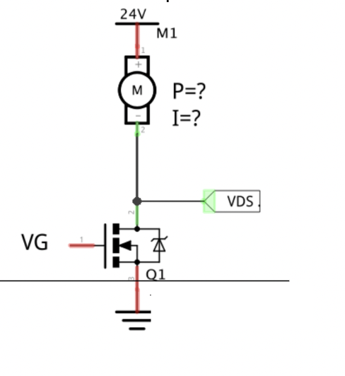

Discussion/Conclusion

From the data collected within this experiment, it can be understood that V_{DS} and V_{GS} both have a significant effect on the current I_{D}. They change the resulting slope, and maximum value proportionally. By conducting this experiment the theorems and key concepts of MOSFETs hold true, allowing them to be correctly used within real world technologies like vehicles. To create a smaller percent error between the calculated and actual values, it may be necessary to collect multiple sets of data for each various V_{GS} values so that the data can be more accurate. From the experiment, the validity for the use of a MOSFET is legitimate. The MOSFET can be used as various components based on how it is set up. This allows for a single item to be used instead of multiple, lowering the complexity of a circuit.

Appendix

Link to Arduino Codes
https://drive.google.com/file/d/1PhrVtKkXf_bsgUI4RNFZpB-hpLaV2I_T/view?usp=drive_link

https://docs.google.com/document/d/1Di7s1iSaPiQIIf9Id1S8hmPqF89lVY5hrNQHrZoirOA/edit?usp=sharing

References

Dr. Yuan Xu. 2023 Fall. MOSFET PCS224 [lab manual]. Toronto (ON): Toronto Metropolitan University

Serway, R. A., & Jewett, J. W. (2018). Physics for scientists and engineers (10th ed.). Cengage Learning.
Toronto Metropolitan University. (n.d.). Physics Lab Guide [PDF]. D2L. https://courses.torontomu.ca/d2l/le/content/795518/viewContent/5278918/View

Unknown. (1994, March). N-CHANNEL ENHANCEMENT MODE VERTICAL DMOS FET. Diodes Incorporated - Analog, Discrete, Logic, Mixed-Signal. https://www.diodes.com/assets/Datasheets/ZVN2106A.pdf

